Gen AI internship (9th feb) – 6pm to 7pm
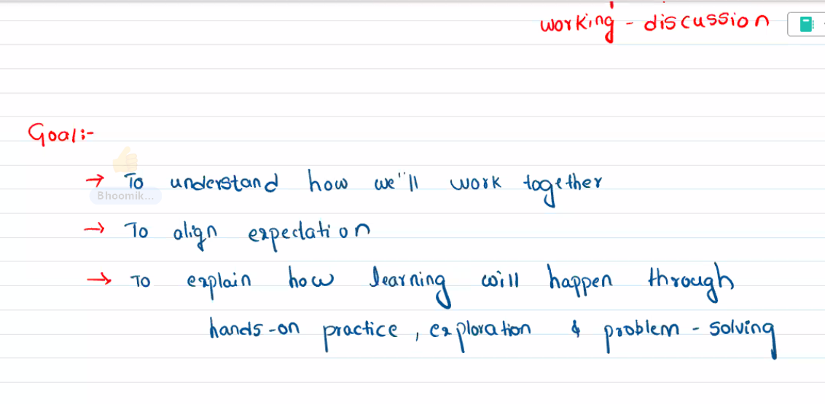
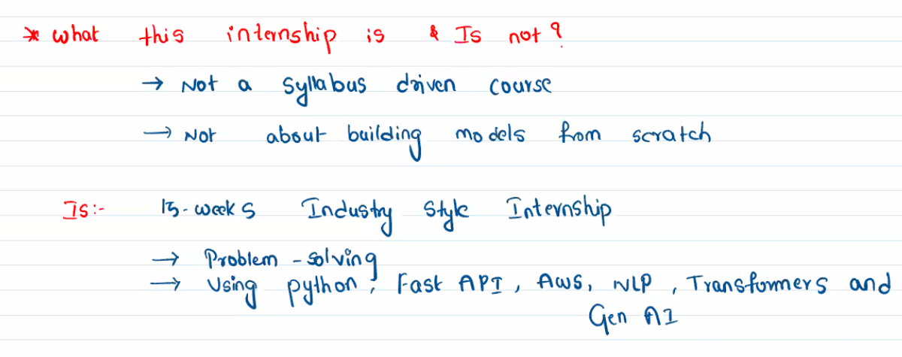
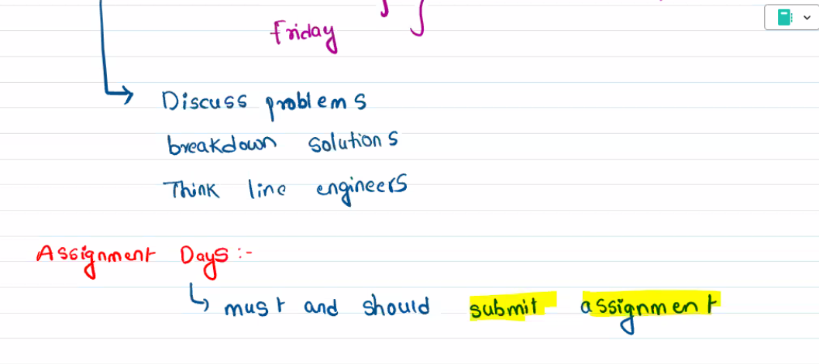
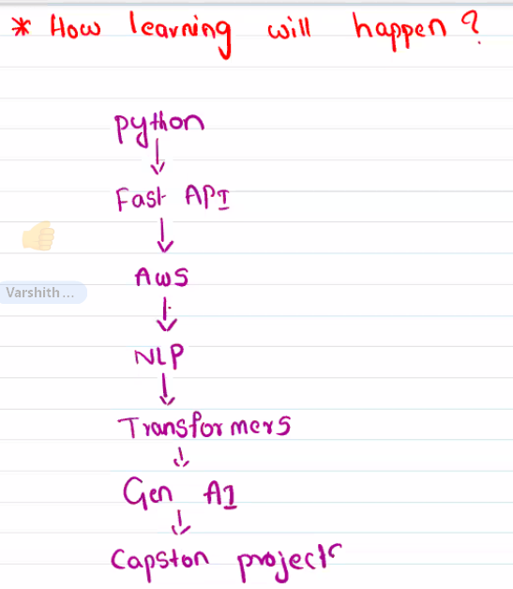
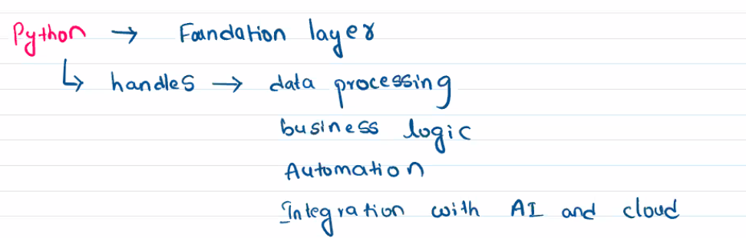
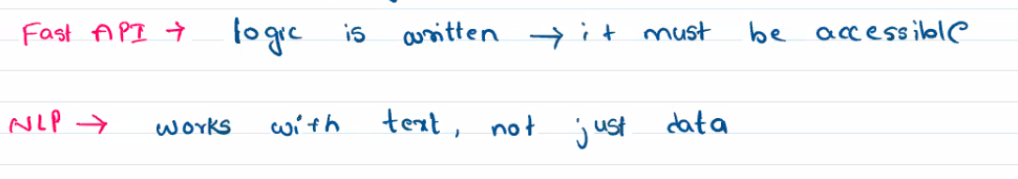
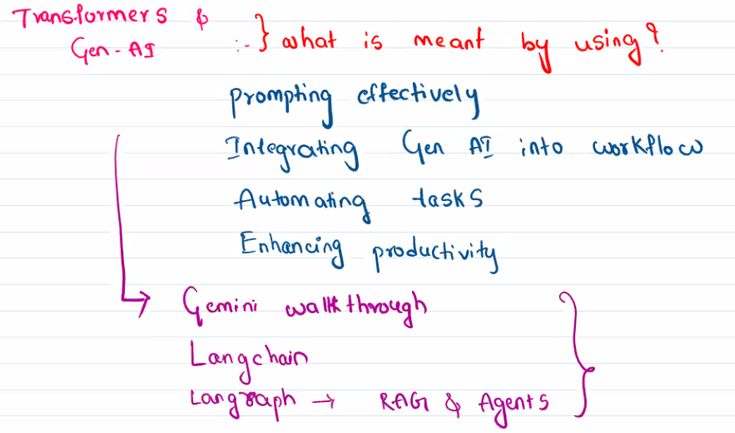
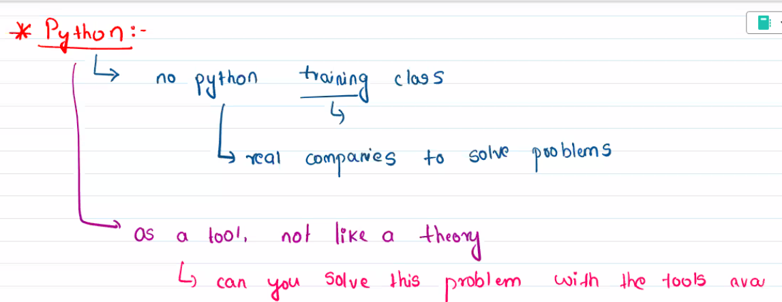
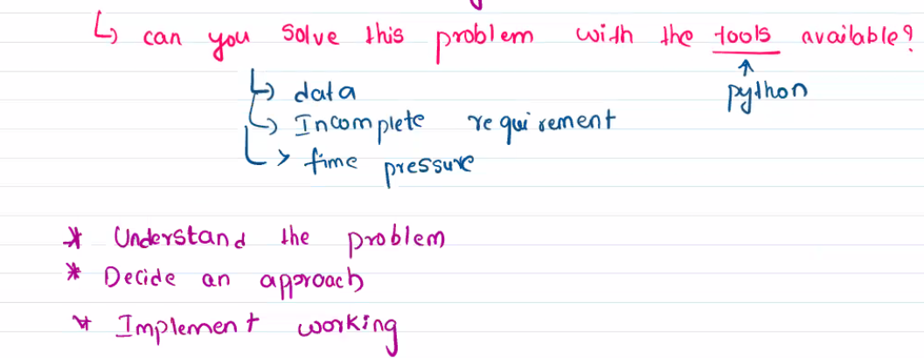
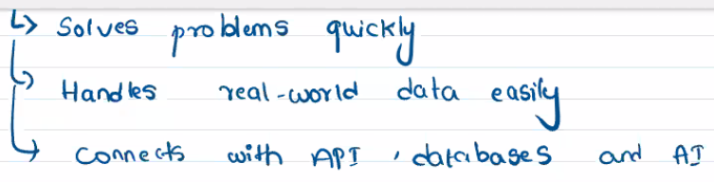
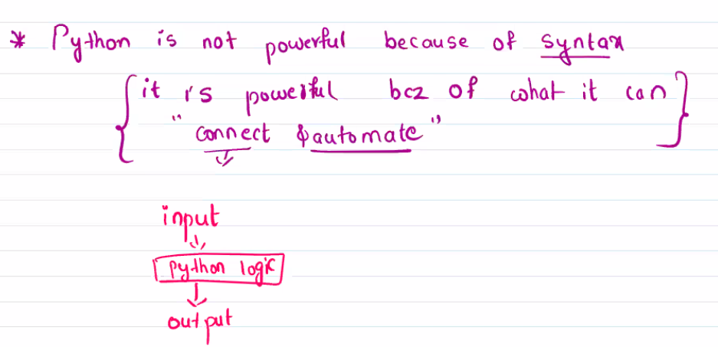
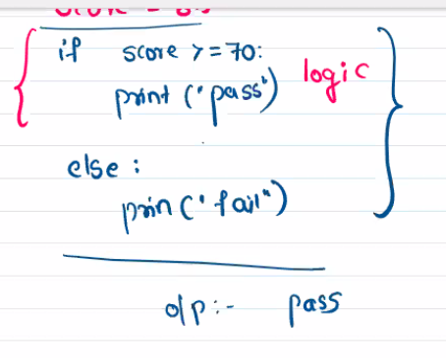
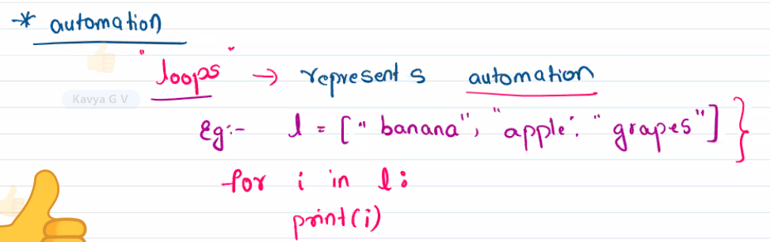
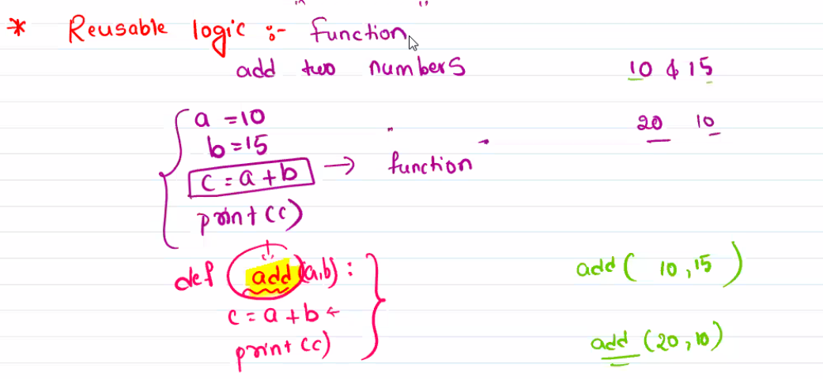
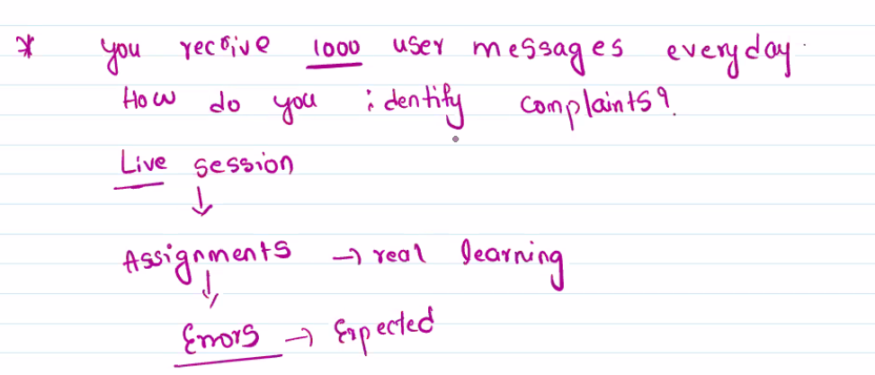

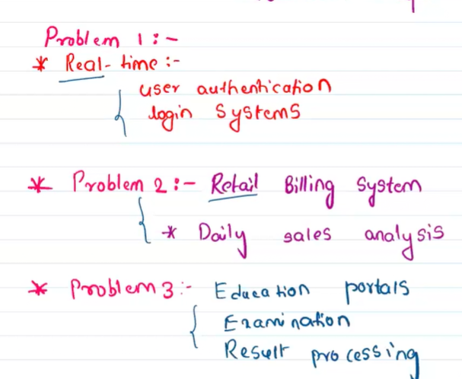
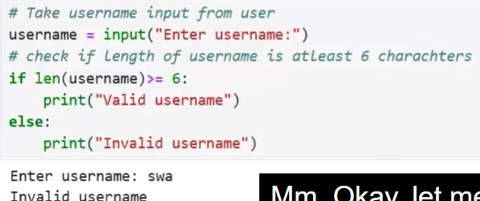
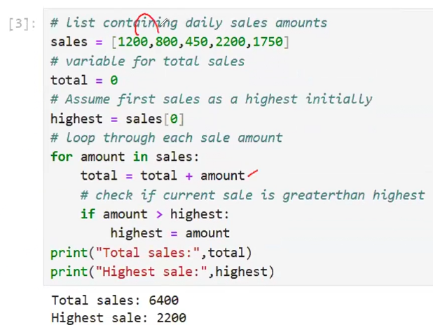
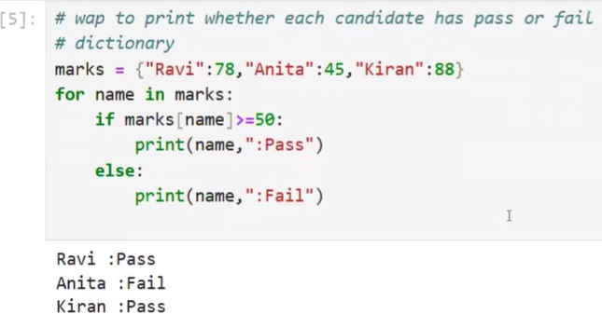
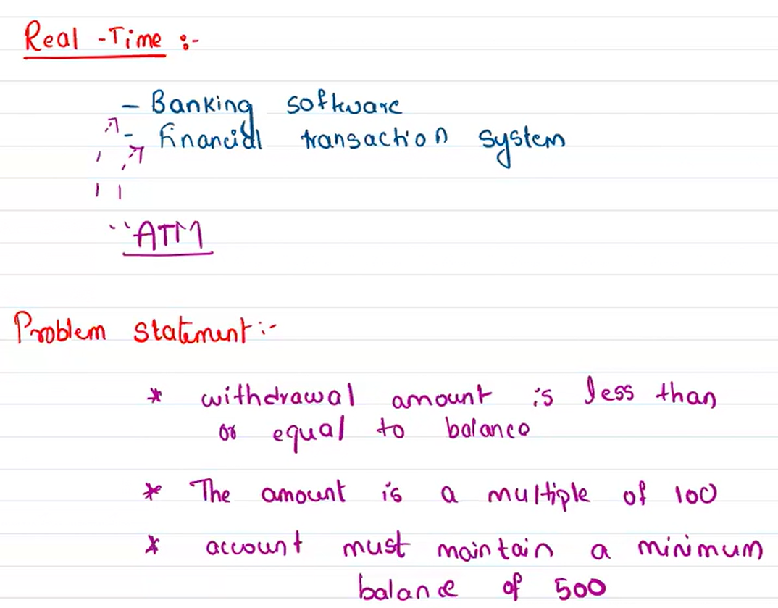
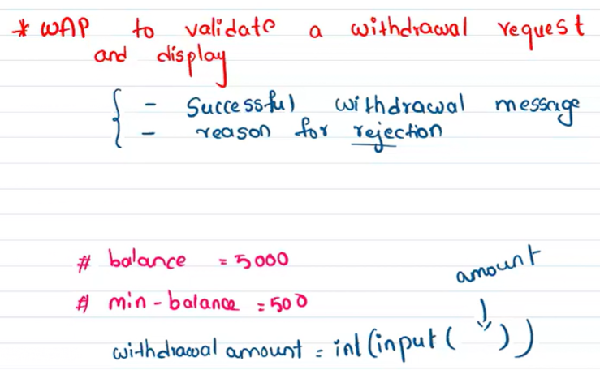
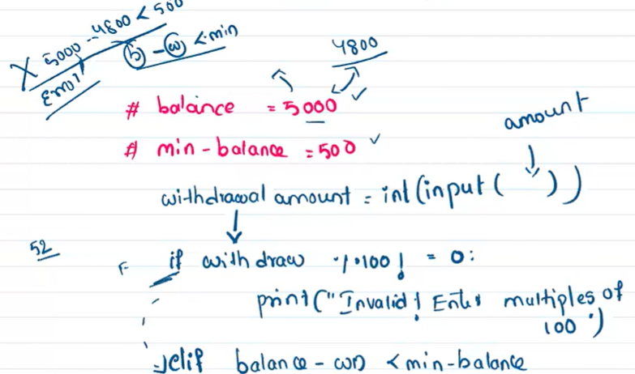
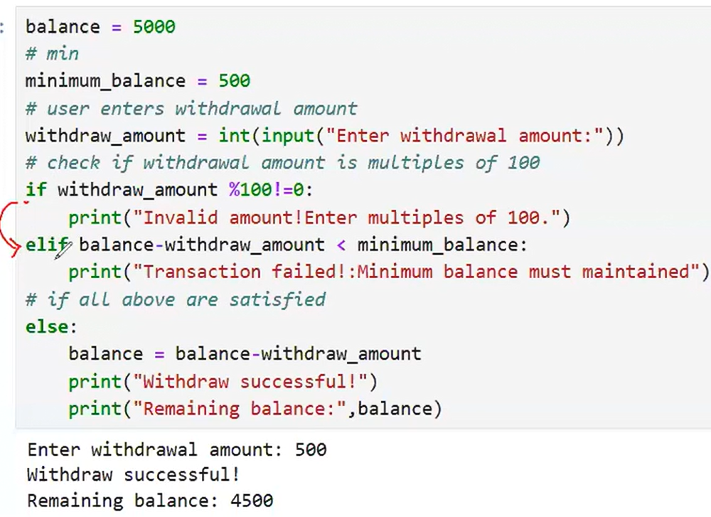
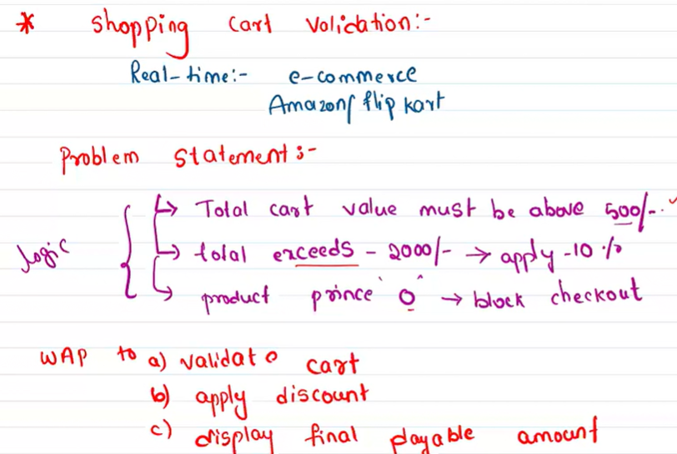
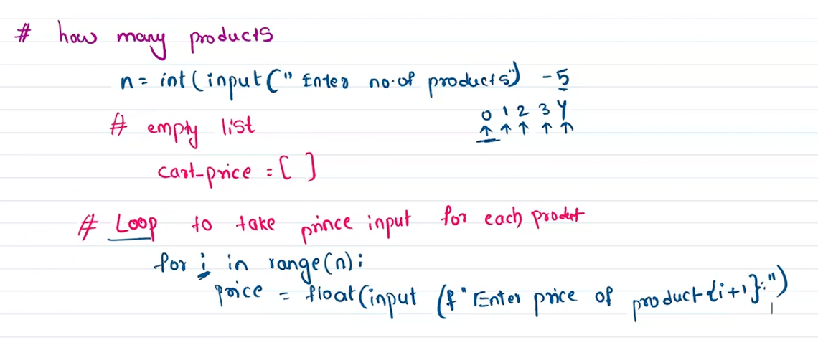
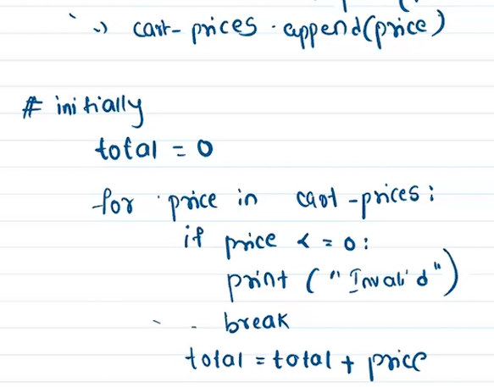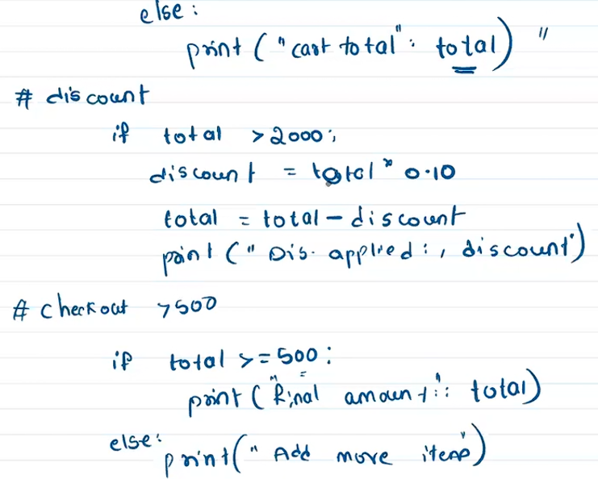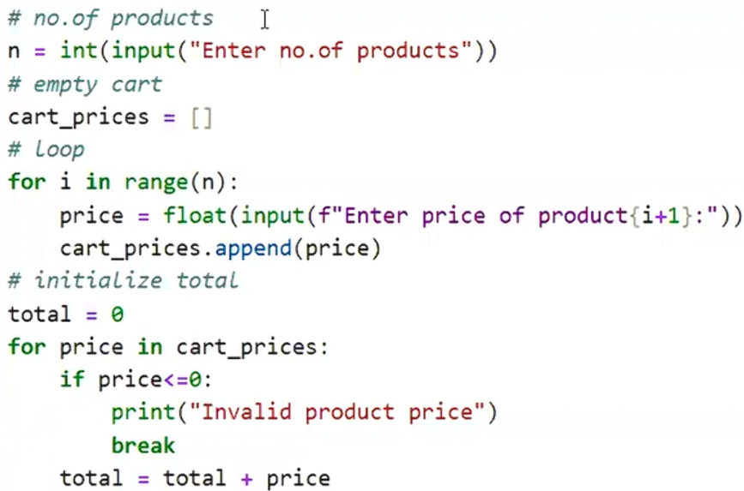
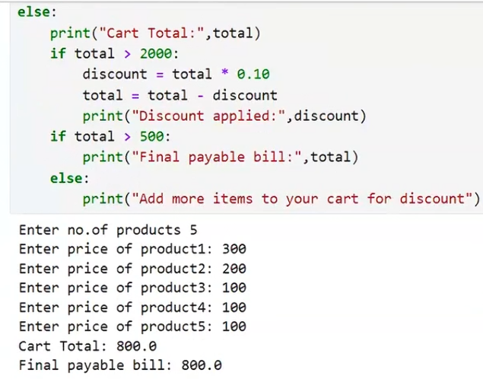

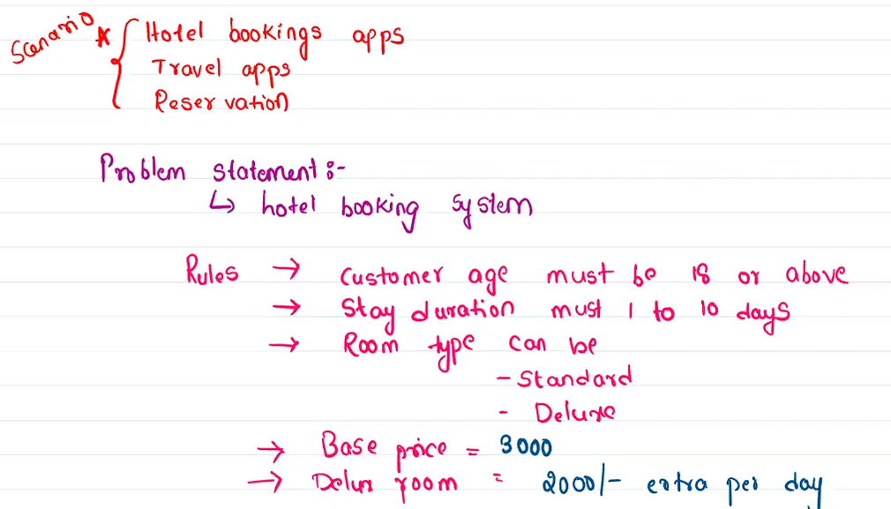

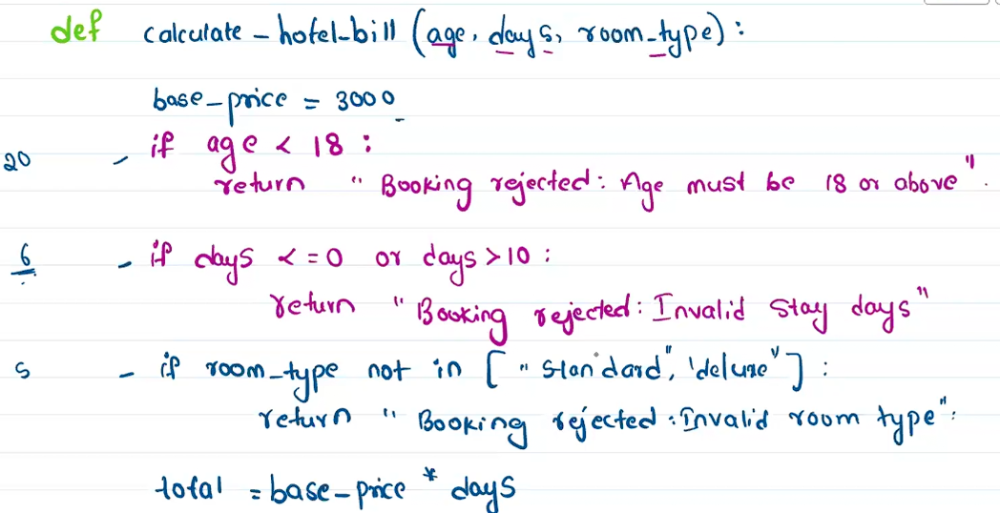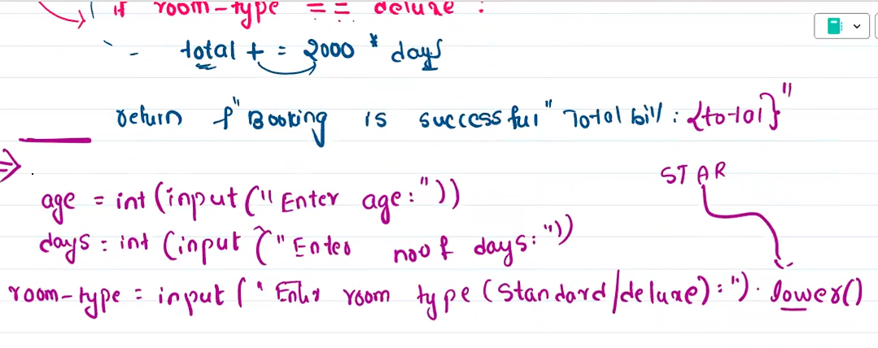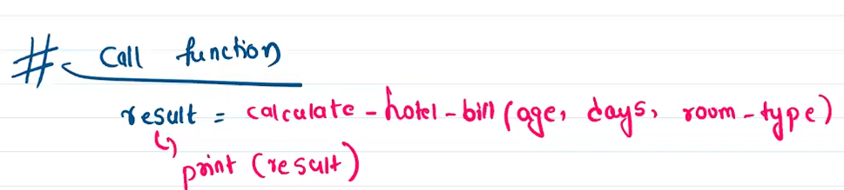
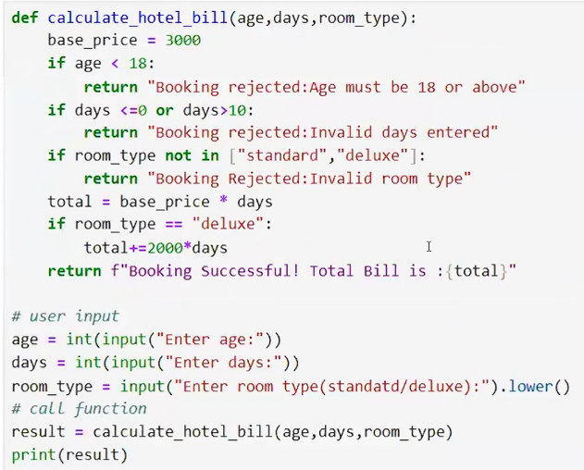
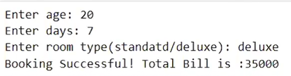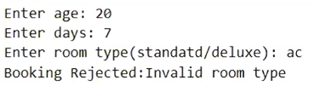
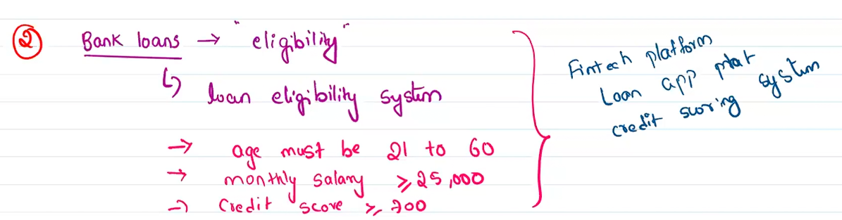
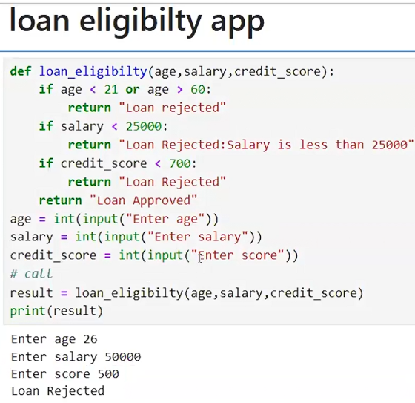

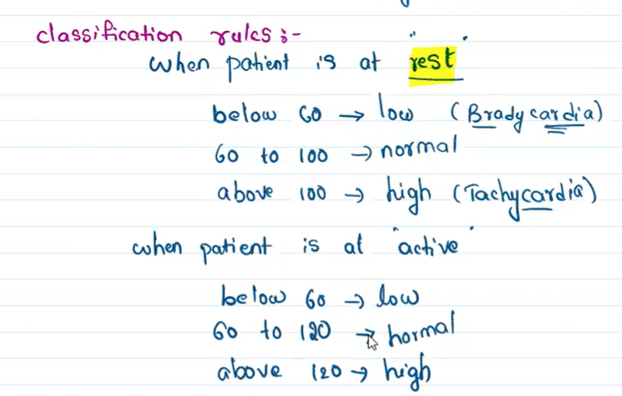
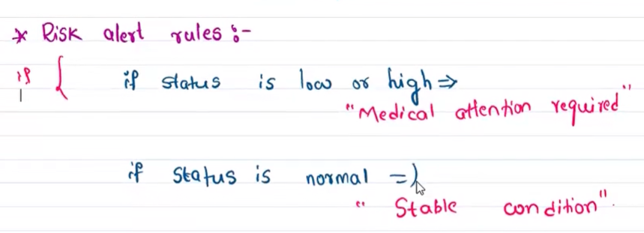
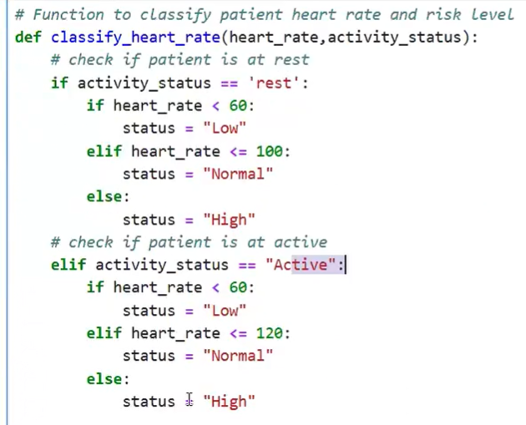
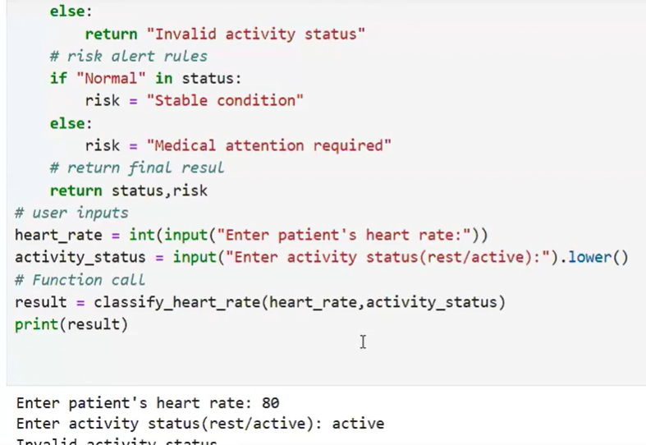
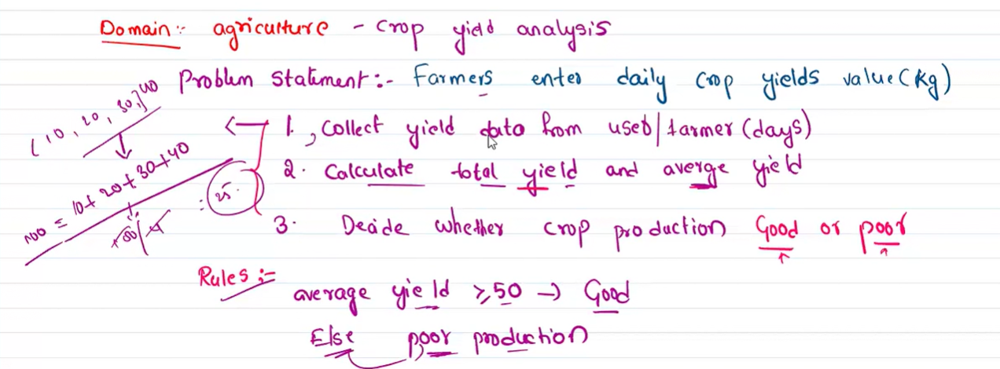
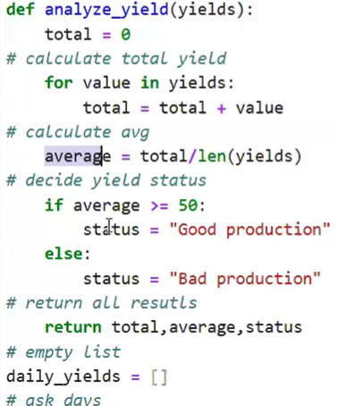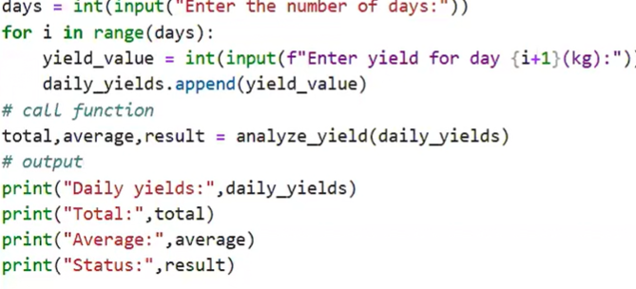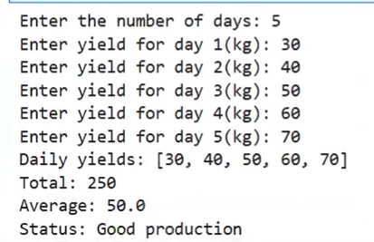
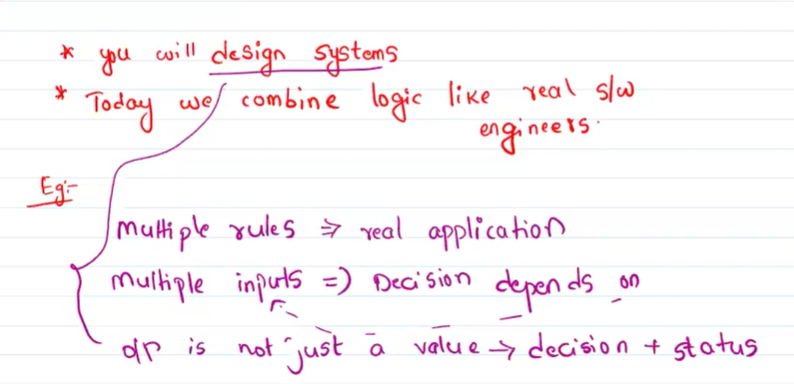
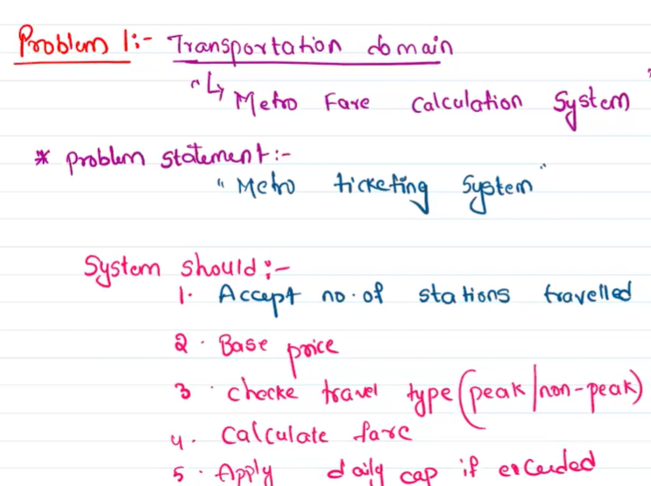
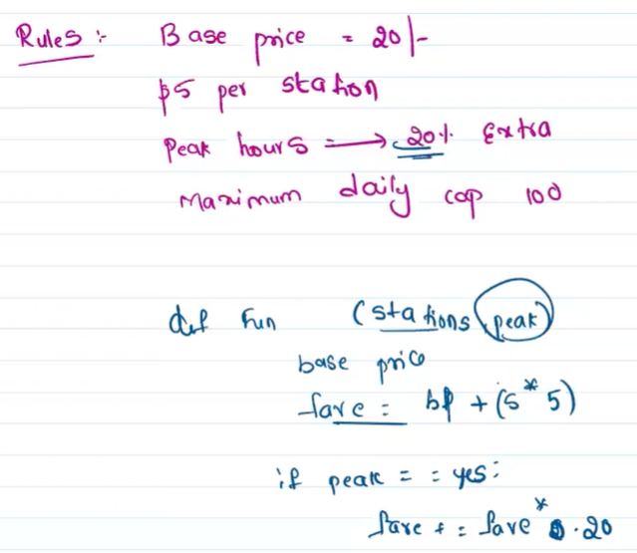
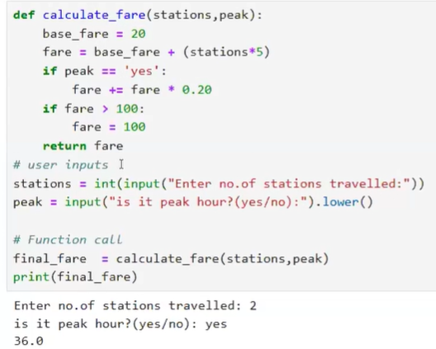
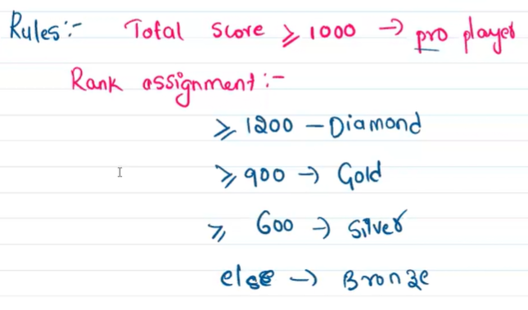
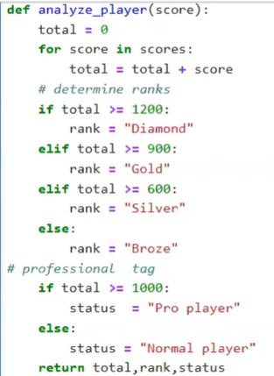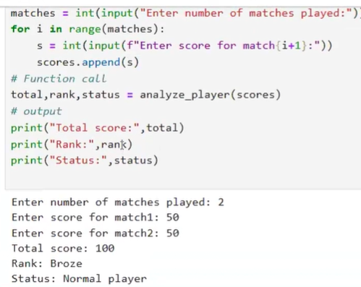
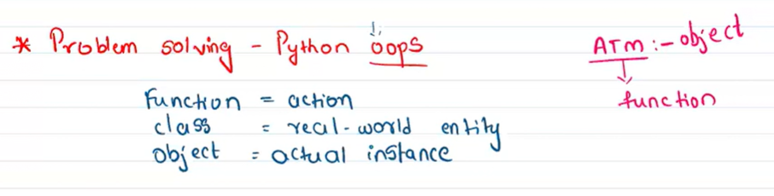
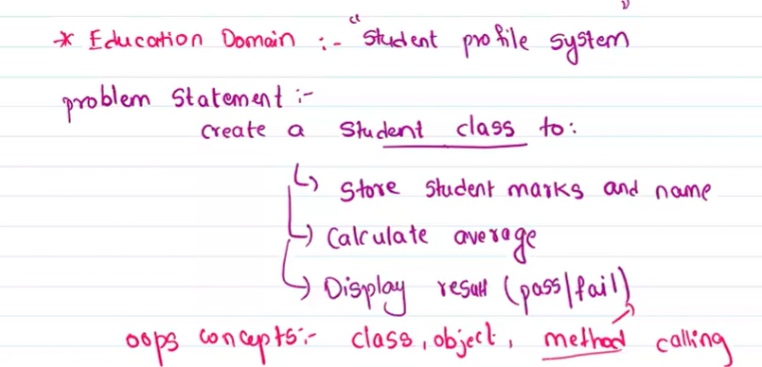
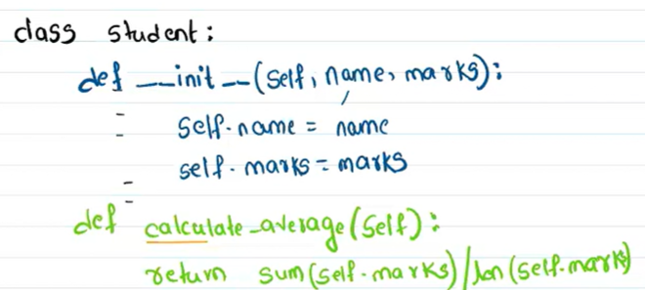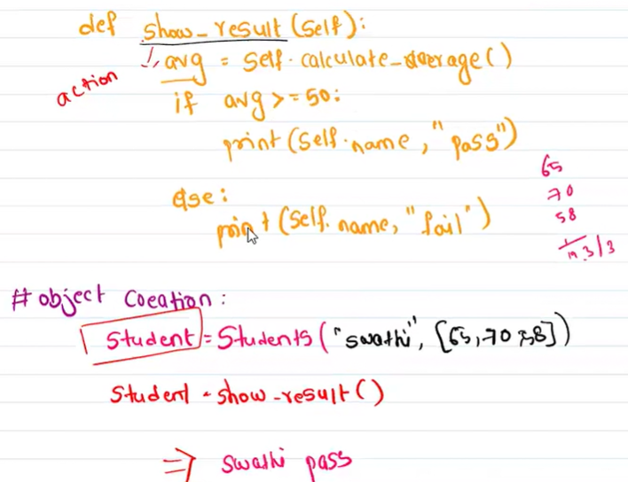
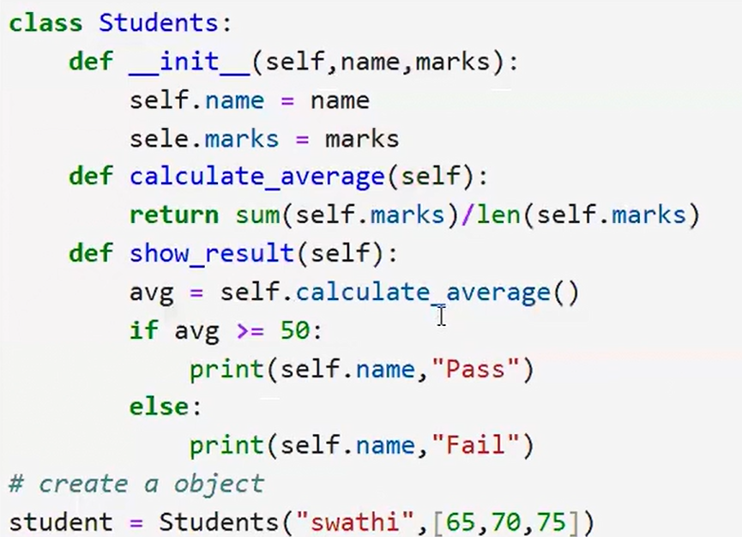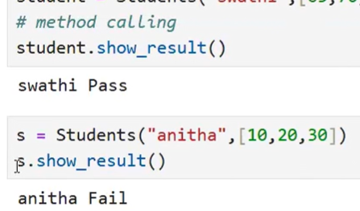
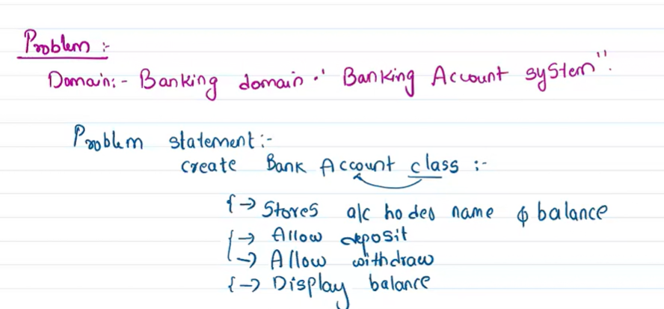
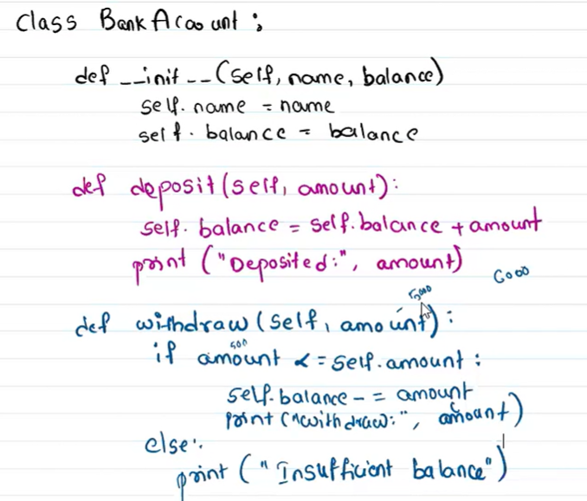
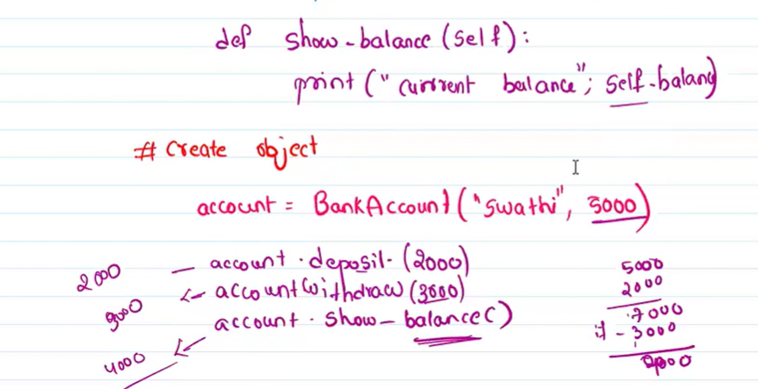
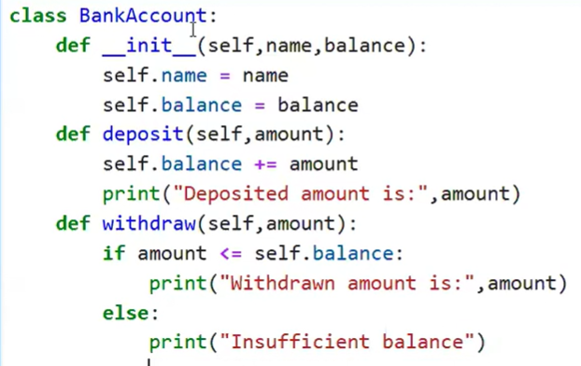
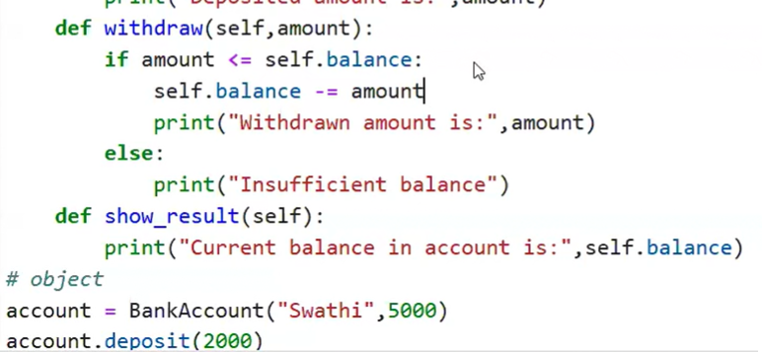
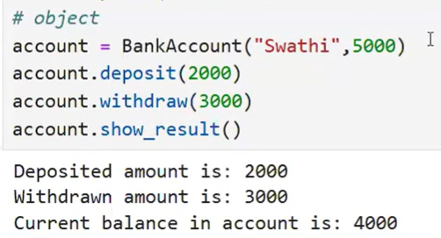
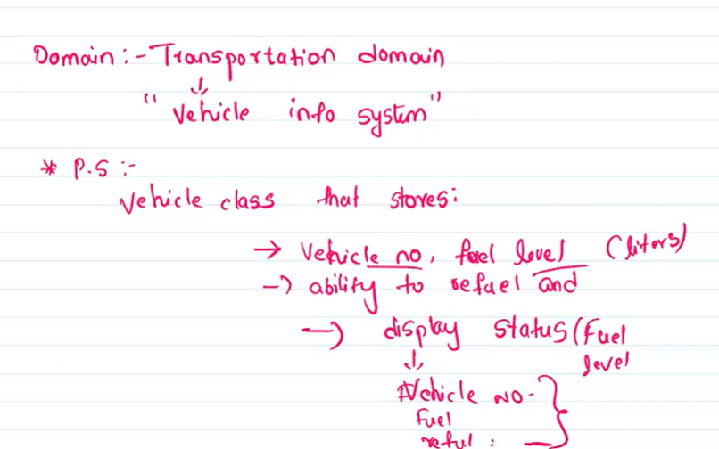
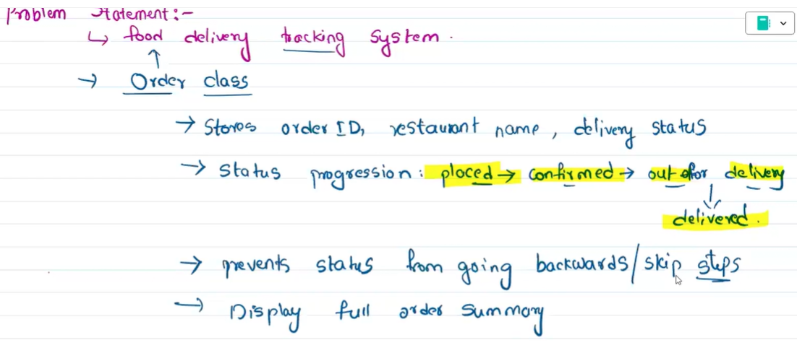
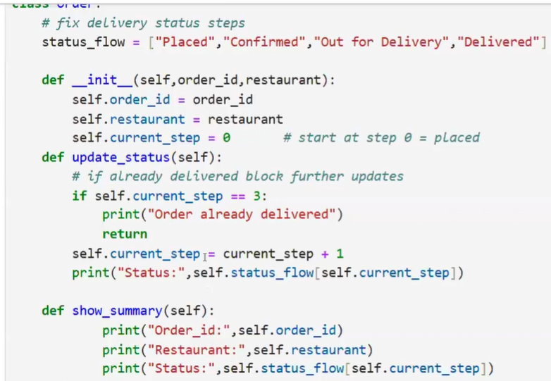
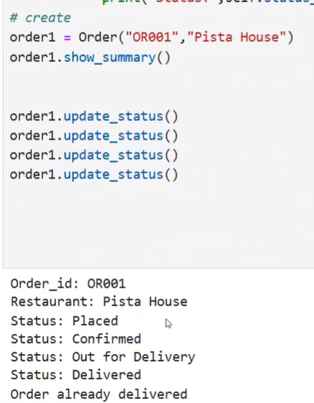
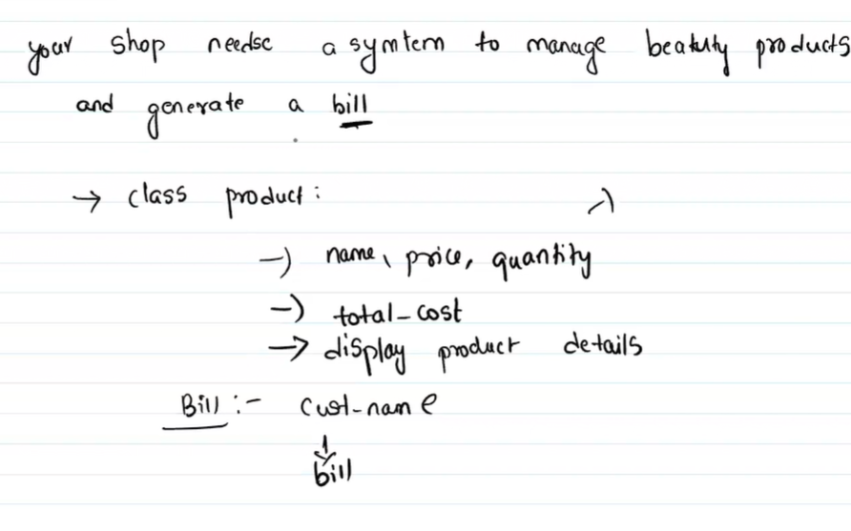
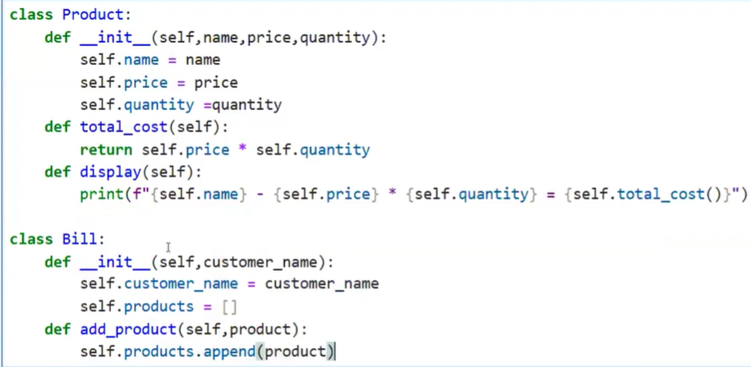
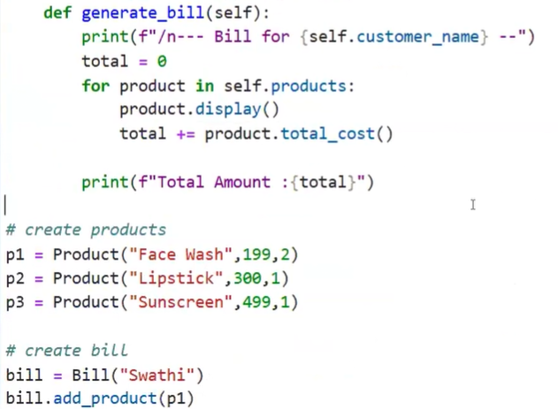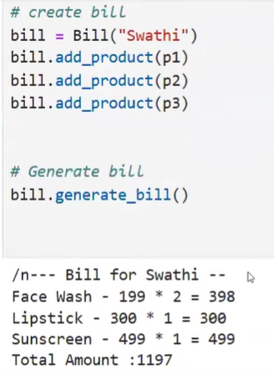

Create project folder --> mkdir folder_name
Create virtual environment inside it. -- >python -m venv venv
Activate --> venv\scripts\activate
Install fast Api --> pip install fastapi uvicorn
Create main.py inside the folder:
from fastapi import FastAPI
app = FastAPI() # app is a variable or object of fastapi class
@app.get("/") #Home / route url
def home():
return {"message": "Welcome to our app"}
Run the main.py --> uvicorn main:app --reload
Uvicorn = Engine for fastapi
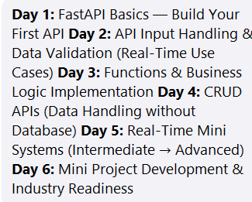
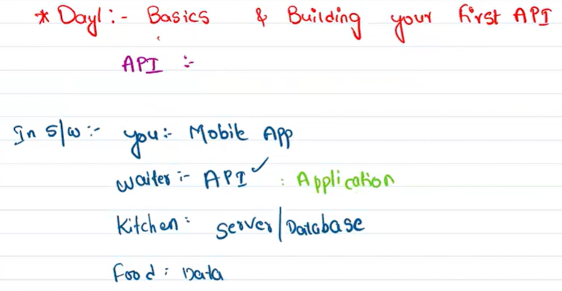



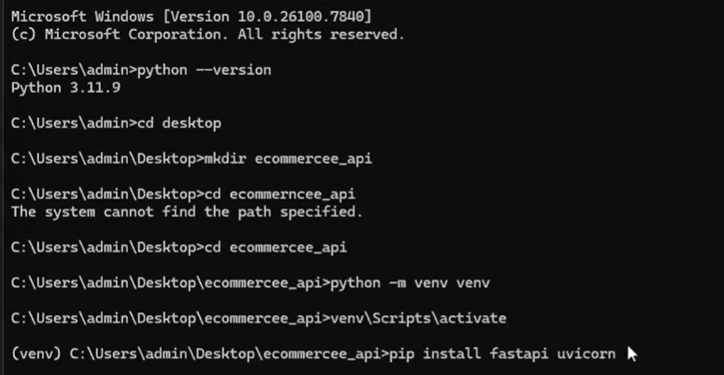
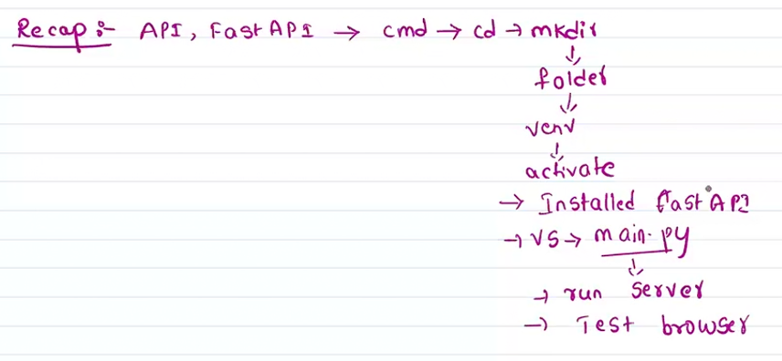
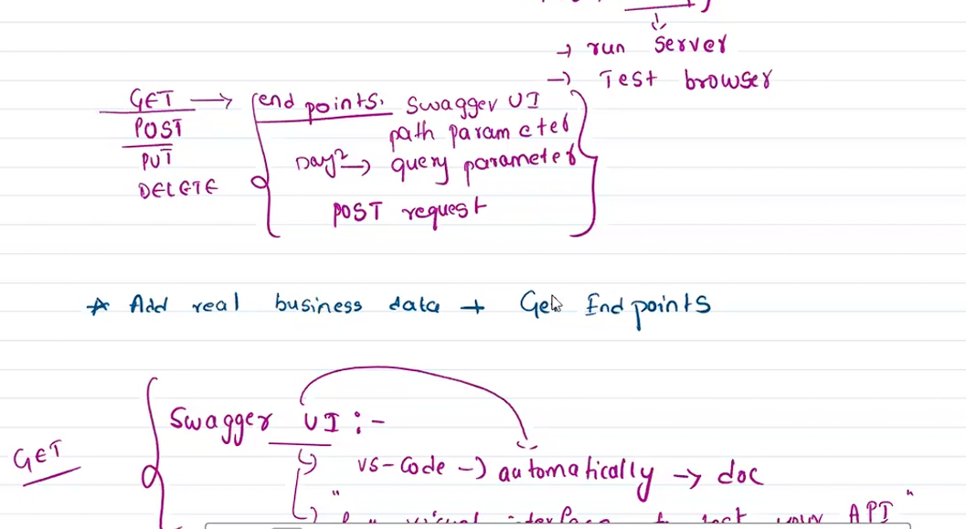
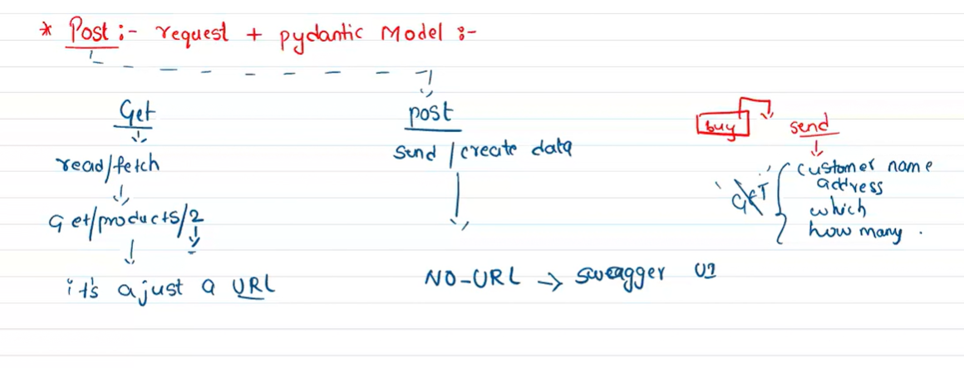
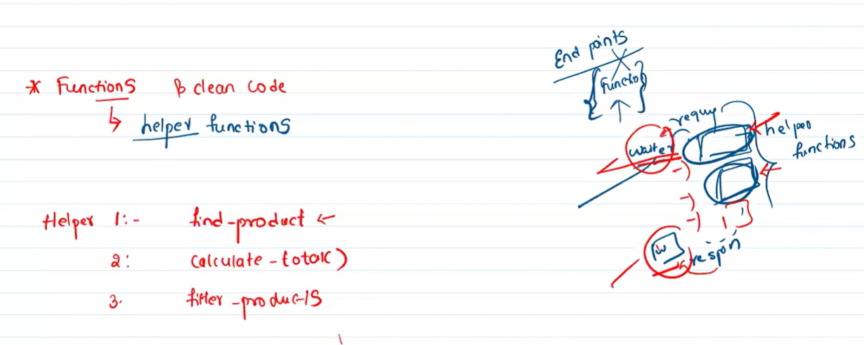
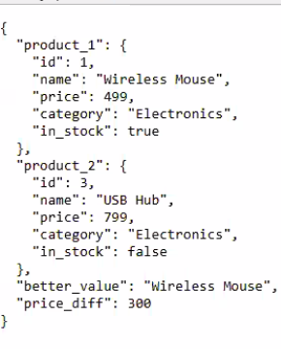
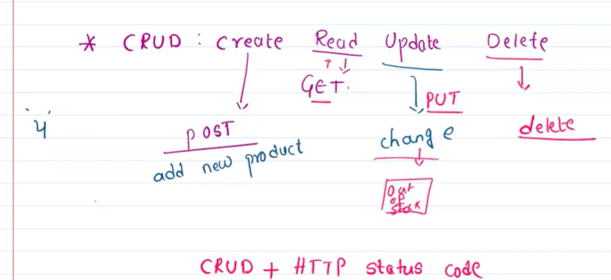
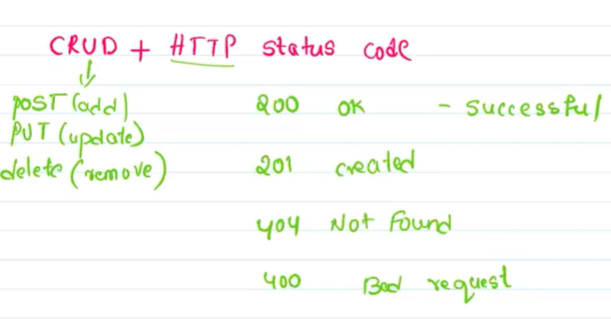
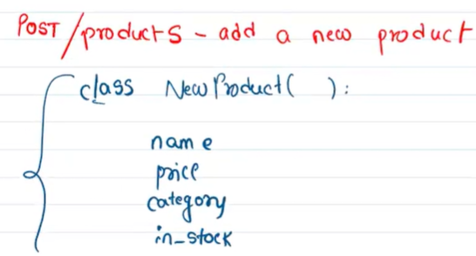
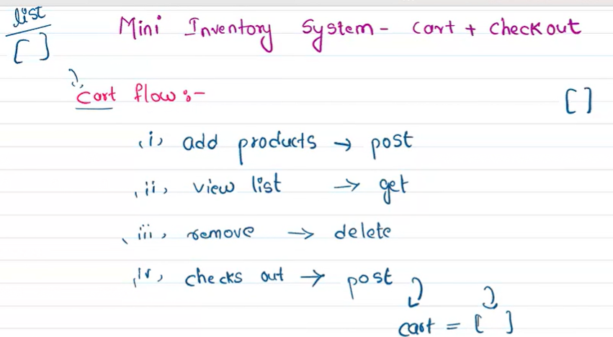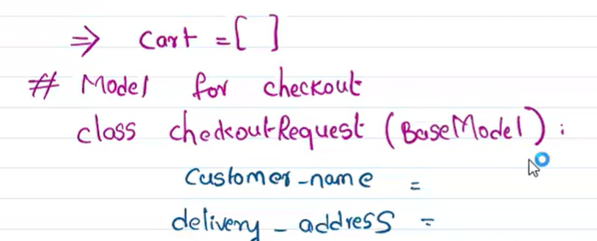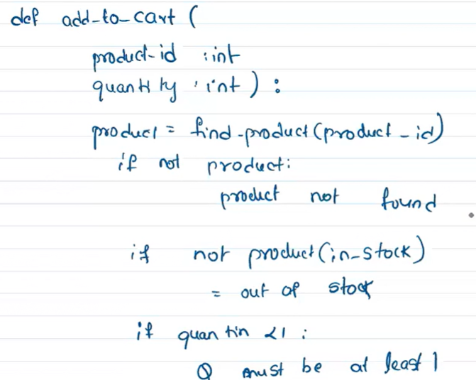
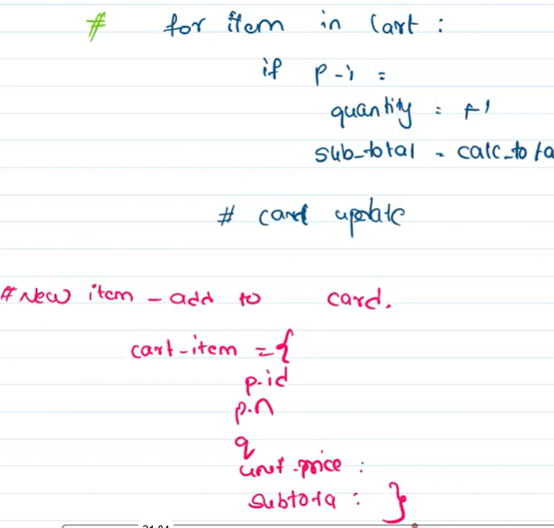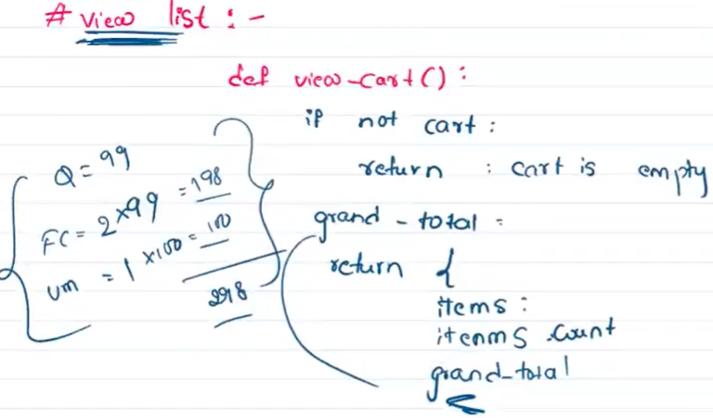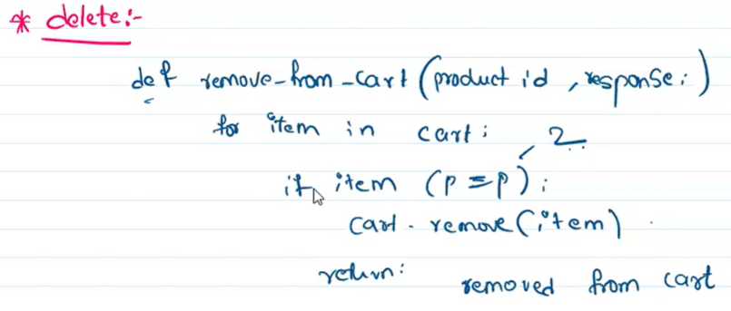
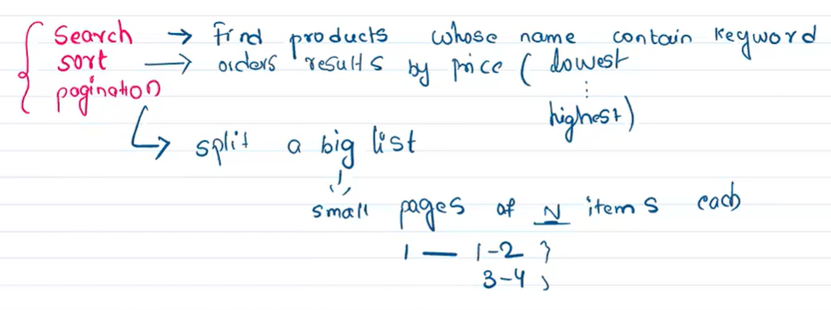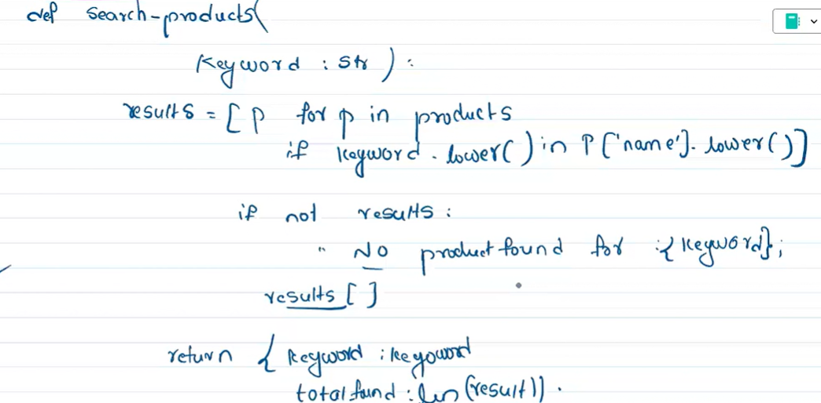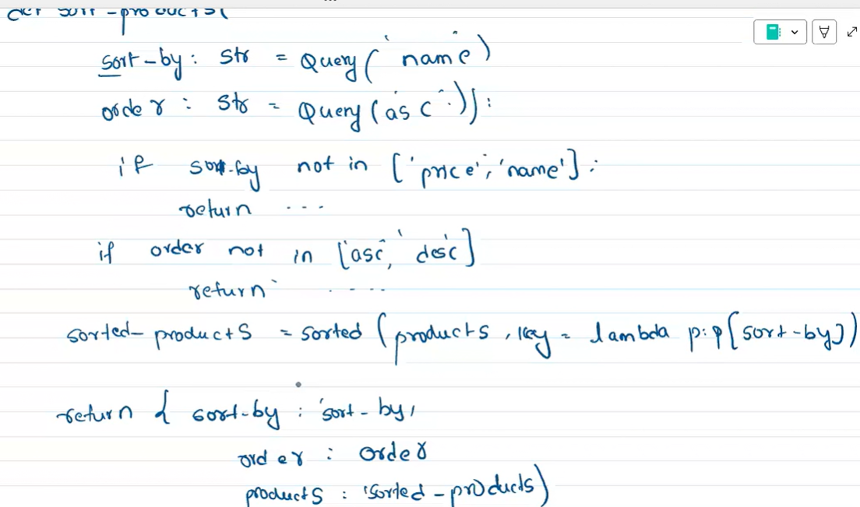
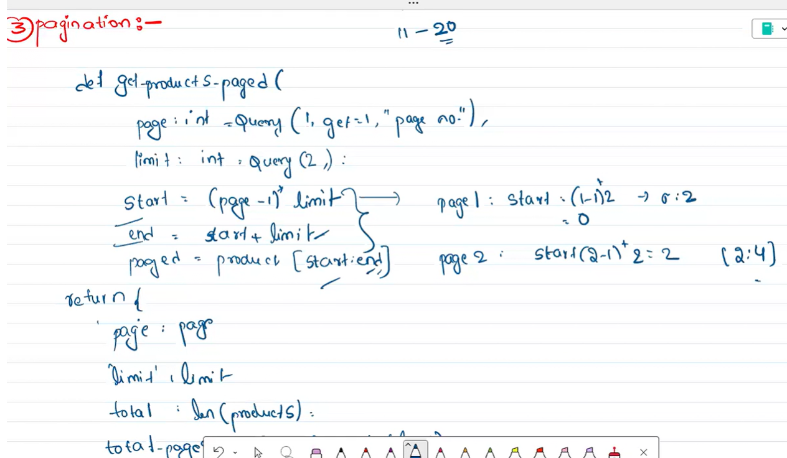

from fastapi import FastAPI, Query, Response, status
from pydantic import BaseModel, Field
app = FastAPI()
# ══ PYDANTIC MODELS ═══════════════════════════════════════════════
class OrderRequest(BaseModel): # Day 2
customer_name: str = Field(..., min_length=2, max_length=100)
product_id: int = Field(..., gt=0)
quantity: int = Field(..., gt=0, le=100)
delivery_address: str = Field(..., min_length=10)
class NewProduct(BaseModel): # Day 4
name: str = Field(..., min_length=2, max_length=100)
price: int = Field(..., gt=0)
category: str = Field(..., min_length=2)
in_stock: bool = True
# ══ DATA ══════════════════════════════════════════════════════════
products = [
{'id': 1, 'name': 'Wireless Mouse', 'price': 499, 'category': 'Electronics', 'in_stock': True},
{'id': 2, 'name': 'Notebook', 'price': 99, 'category': 'Stationery', 'in_stock': True},
{'id': 3, 'name': 'USB Hub', 'price': 799, 'category': 'Electronics', 'in_stock': False},
{'id': 4, 'name': 'Pen Set', 'price': 49, 'category': 'Stationery', 'in_stock': True},
]
orders = []
order_counter = 1
# ══ HELPER FUNCTIONS ══════════════════════════════════════════════
def find_product(product_id: int):
"""Search products list by ID. Returns product dict or None."""
for p in products:
if p['id'] == product_id:
return p
return None
def calculate_total(product: dict, quantity: int) -> int:
"""Multiply price by quantity and return total."""
return product['price'] * quantity
def filter_products_logic(category=None, min_price=None,
max_price=None, in_stock=None):
"""Apply filters and return matching products."""
result = products
if category is not None:
result = [p for p in result if p['category'] == category]
if min_price is not None:
result = [p for p in result if p['price'] >= min_price]
if max_price is not None:
result = [p for p in result if p['price'] <= max_price]
if in_stock is not None:
result = [p for p in result if p['in_stock'] == in_stock]
return result
# ══ ENDPOINTS ═════════════════════════════════════════════════════
#
# ROUTE ORDER RULE — FastAPI reads top to bottom, first match wins.
# Fixed routes (/filter /compare /audit /discount) BEFORE variable (/{product_id})
#
# ══════════════════════════════════════════════════════════════════
# ── DAY 1 ─────────────────────────────────────────────────────────
@app.get('/')
def home():
return {'message': 'Welcome to our E-commerce API'}
@app.get('/products')
def get_all_products():
return {'products': products, 'total': len(products)}
# ── DAY 2 — Filter ────────────────────────────────────────────────
@app.get('/products/filter')
def filter_products(
category: str = Query(None, description='Electronics or Stationery'),
min_price: int = Query(None, description='Minimum price'),
max_price: int = Query(None, description='Maximum price'),
in_stock: bool = Query(None, description='True = in stock only'),
):
result = filter_products_logic(category, min_price, max_price, in_stock)
return {'filtered_products': result, 'count': len(result)}
# ── DAY 3 — Compare ───────────────────────────────────────────────
@app.get('/products/compare')
def compare_products(
product_id_1: int = Query(..., description='First product ID'),
product_id_2: int = Query(..., description='Second product ID'),
):
p1 = find_product(product_id_1)
p2 = find_product(product_id_2)
if not p1:
return {'error': f'Product {product_id_1} not found'}
if not p2:
return {'error': f'Product {product_id_2} not found'}
cheaper = p1 if p1['price'] < p2['price'] else p2
return {
'product_1': p1,
'product_2': p2,
'better_value': cheaper['name'],
'price_diff': abs(p1['price'] - p2['price']),
}
# ── DAY 4 — Step 18: Add a new product (POST) ─────────────────────
@app.post('/products')
def add_product(new_product: NewProduct, response: Response):
# Check for duplicate name (case-insensitive)
existing_names = [p['name'].lower() for p in products]
if new_product.name.lower() in existing_names:
response.status_code = status.HTTP_400_BAD_REQUEST
return {'error': 'Product with this name already exists'}
# Auto-generate next ID
next_id = max(p['id'] for p in products) + 1
product = {
'id': next_id,
'name': new_product.name,
'price': new_product.price,
'category': new_product.category,
'in_stock': new_product.in_stock,
}
products.append(product)
response.status_code = status.HTTP_201_CREATED
return {'message': 'Product added', 'product': product}
# ── DAY 4 — Step 19: Update stock or price (PUT) ──────────────────
@app.put('/products/{product_id}')
def update_product(
product_id: int,
response: Response,
in_stock: bool = Query(None, description='Update stock status'),
price: int = Query(None, description='Update price'),
):
product = find_product(product_id)
if not product:
response.status_code = status.HTTP_404_NOT_FOUND
return {'error': 'Product not found'}
if in_stock is not None: # must use 'is not None' — False is a valid value
product['in_stock'] = in_stock
if price is not None:
product['price'] = price
return {'message': 'Product updated', 'product': product}
# ── DAY 4 — Step 20: Delete a product (DELETE) ────────────────────
@app.delete('/products/{product_id}')
def delete_product(product_id: int, response: Response):
product = find_product(product_id)
if not product:
response.status_code = status.HTTP_404_NOT_FOUND
return {'error': 'Product not found'}
products.remove(product)
return {'message': f"Product '{product['name']}' deleted"}
# ── DAY 1 — Get single product ────────────────────────────────────
# Variable route — always AFTER all fixed routes above
@app.get('/products/{product_id}')
def get_product(product_id: int):
product = find_product(product_id)
if not product:
return {'error': 'Product not found'}
return {'product': product}
# ── DAY 2 — Place order ───────────────────────────────────────────
@app.post('/orders')
def place_order(order_data: OrderRequest):
global order_counter
product = find_product(order_data.product_id)
if not product:
return {'error': 'Product not found'}
if not product['in_stock']:
return {'error': f"{product['name']} is out of stock"}
total = calculate_total(product, order_data.quantity)
order = {
'order_id': order_counter,
'customer_name': order_data.customer_name,
'product': product['name'],
'quantity': order_data.quantity,
'delivery_address': order_data.delivery_address,
'total_price': total,
'status': 'confirmed',
}
orders.append(order)
order_counter += 1
return {'message': 'Order placed successfully', 'order': order}
@app.get('/orders')
def get_all_orders():
return {'orders': orders, 'total_orders': len(orders)}
from fastapi import FastAPI, Query, Response, status
from pydantic import BaseModel, Field
app = FastAPI()
# ══ PYDANTIC MODELS ═══════════════════════════════════════════════
class OrderRequest(BaseModel): # Day 2
customer_name: str = Field(..., min_length=2, max_length=100)
product_id: int = Field(..., gt=0)
quantity: int = Field(..., gt=0, le=100)
delivery_address: str = Field(..., min_length=10)
class NewProduct(BaseModel): # Day 4
name: str = Field(..., min_length=2, max_length=100)
price: int = Field(..., gt=0)
category: str = Field(..., min_length=2)
in_stock: bool = True
# ══ DATA ══════════════════════════════════════════════════════════
products = [
{'id': 1, 'name': 'Wireless Mouse', 'price': 499, 'category': 'Electronics', 'in_stock': True},
{'id': 2, 'name': 'Notebook', 'price': 99, 'category': 'Stationery', 'in_stock': True},
{'id': 3, 'name': 'USB Hub', 'price': 799, 'category': 'Electronics', 'in_stock': False},
{'id': 4, 'name': 'Pen Set', 'price': 49, 'category': 'Stationery', 'in_stock': True},
]
orders = []
order_counter = 1
# ══ HELPER FUNCTIONS ══════════════════════════════════════════════
def find_product(product_id: int):
"""Search products list by ID. Returns product dict or None."""
for p in products:
if p['id'] == product_id:
return p
return None
def calculate_total(product: dict, quantity: int) -> int:
"""Multiply price by quantity and return total."""
return product['price'] * quantity
def filter_products_logic(category=None, min_price=None,
max_price=None, in_stock=None):
"""Apply filters and return matching products."""
result = products
if category is not None:
result = [p for p in result if p['category'] == category]
if min_price is not None:
result = [p for p in result if p['price'] >= min_price]
if max_price is not None:
result = [p for p in result if p['price'] <= max_price]
if in_stock is not None:
result = [p for p in result if p['in_stock'] == in_stock]
return result
# ══ ENDPOINTS ═════════════════════════════════════════════════════
#
# ROUTE ORDER RULE — FastAPI reads top to bottom, first match wins.
# Fixed routes (/filter /compare /audit /discount) BEFORE variable (/{product_id})
#
# ══════════════════════════════════════════════════════════════════
# ── DAY 1 ─────────────────────────────────────────────────────────
@app.get('/')
def home():
return {'message': 'Welcome to our E-commerce API'}
@app.get('/products')
def get_all_products():
return {'products': products, 'total': len(products)}
# ── DAY 2 — Filter ────────────────────────────────────────────────
@app.get('/products/filter')
def filter_products(
category: str = Query(None, description='Electronics or Stationery'),
min_price: int = Query(None, description='Minimum price'),
max_price: int = Query(None, description='Maximum price'),
in_stock: bool = Query(None, description='True = in stock only'),
):
result = filter_products_logic(category, min_price, max_price, in_stock)
return {'filtered_products': result, 'count': len(result)}
# ── DAY 3 — Compare ───────────────────────────────────────────────
@app.get('/products/compare')
def compare_products(
product_id_1: int = Query(..., description='First product ID'),
product_id_2: int = Query(..., description='Second product ID'),
):
p1 = find_product(product_id_1)
p2 = find_product(product_id_2)
if not p1:
return {'error': f'Product {product_id_1} not found'}
if not p2:
return {'error': f'Product {product_id_2} not found'}
cheaper = p1 if p1['price'] < p2['price'] else p2
return {
'product_1': p1,
'product_2': p2,
'better_value': cheaper['name'],
'price_diff': abs(p1['price'] - p2['price']),
}
# ── DAY 4 — Step 18: Add a new product (POST) ─────────────────────
@app.post('/products')
def add_product(new_product: NewProduct, response: Response):
# Check for duplicate name (case-insensitive)
existing_names = [p['name'].lower() for p in products]
if new_product.name.lower() in existing_names:
response.status_code = status.HTTP_400_BAD_REQUEST
return {'error': 'Product with this name already exists'}
# Auto-generate next ID
next_id = max(p['id'] for p in products) + 1
product = {
'id': next_id,
'name': new_product.name,
'price': new_product.price,
'category': new_product.category,
'in_stock': new_product.in_stock,
}
products.append(product)
response.status_code = status.HTTP_201_CREATED
return {'message': 'Product added', 'product': product}
# ── DAY 4 — Step 19: Update stock or price (PUT) ──────────────────
@app.put('/products/{product_id}')
def update_product(
product_id: int,
response: Response,
in_stock: bool = Query(None, description='Update stock status'),
price: int = Query(None, description='Update price'),
):
product = find_product(product_id)
if not product:
response.status_code = status.HTTP_404_NOT_FOUND
return {'error': 'Product not found'}
if in_stock is not None: # must use 'is not None' — False is a valid value
product['in_stock'] = in_stock
if price is not None:
product['price'] = price
return {'message': 'Product updated', 'product': product}
# ── DAY 4 — Step 20: Delete a product (DELETE) ────────────────────
@app.delete('/products/{product_id}')
def delete_product(product_id: int, response: Response):
product = find_product(product_id)
if not product:
response.status_code = status.HTTP_404_NOT_FOUND
return {'error': 'Product not found'}
products.remove(product)
return {'message': f"Product '{product['name']}' deleted"}
# ── DAY 1 — Get single product ────────────────────────────────────
# Variable route — always AFTER all fixed routes above
@app.get('/products/{product_id}')
def get_product(product_id: int):
product = find_product(product_id)
if not product:
return {'error': 'Product not found'}
return {'product': product}
# ── DAY 2 — Place order ───────────────────────────────────────────
@app.post('/orders')
def place_order(order_data: OrderRequest):
global order_counter
product = find_product(order_data.product_id)
if not product:
return {'error': 'Product not found'}
if not product['in_stock']:
return {'error': f"{product['name']} is out of stock"}
total = calculate_total(product, order_data.quantity)
order = {
'order_id': order_counter,
'customer_name': order_data.customer_name,
'product': product['name'],
'quantity': order_data.quantity,
'delivery_address': order_data.delivery_address,
'total_price': total,
'status': 'confirmed',
}
orders.append(order)
order_counter += 1
return {'message': 'Order placed successfully', 'order': order}
@app.get('/orders')
def get_all_orders():
return {'orders': orders, 'total_orders': len(orders)}

